Terraform-01

1). Install Terraform on your PC
Download Terraform → Windows AMD64
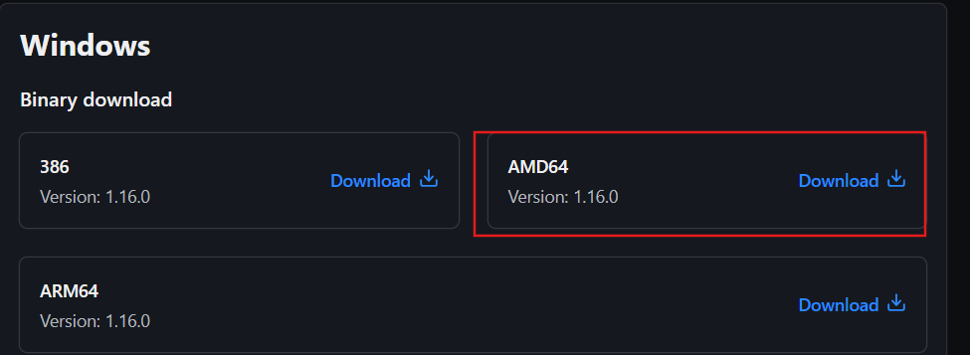
https://developer.hashicorp.com/terraform/install

- Extract terraform.exe to: C:\Terraform
- Open Environment Variables
  - Search → Environment Variables
  - System Properties → Environment Variables
- Under System variables → Path → Edit → New,
add: C:\Terraform
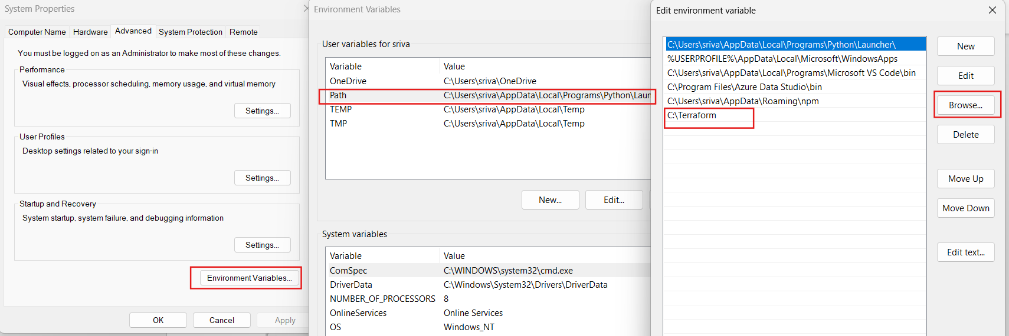

- Click OK → OK → OK
- Close and reopen PowerShell
- Verify:
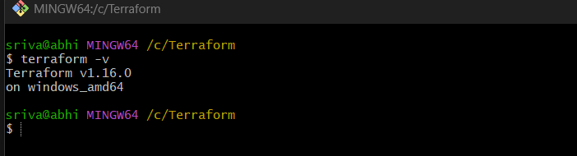
terraform –version

2). Execute all the templates shown in video.
Terraform Template Execution in VS Code
1. Create a folder
C:\Users\sriva\Desktop\Terraform_basic
2. Open the folder in VS Code
- VS Code → File → Open Folder
- Select Terraform_basic
3. Create main.tf
Paste:
resource "local_file" "my_pet" {
filename = "C:/Users/sriva/Desktop/Terraform_basic/my_pet.txt"
content = "my pet is a dog"
}
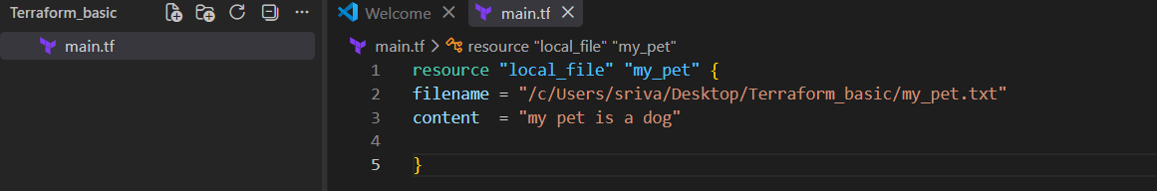
4. Open VS Code Terminal
Go to:
Terminal → New Terminal
Make sure you are in:
PS C:\Users\sriva\Desktop\Terraform_basic>
5. Initialize
terraform init
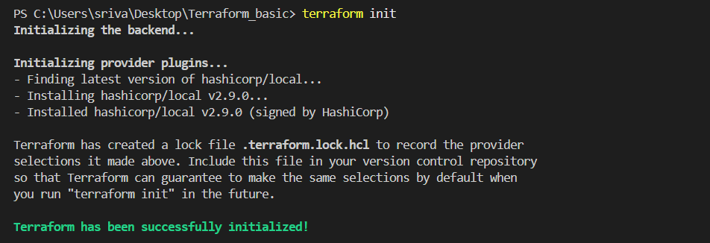
6. Check the plan
terraform plan
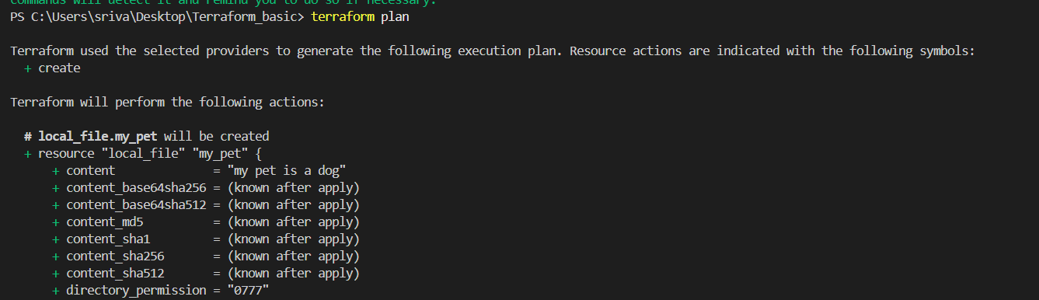
7. Execute
terraform apply
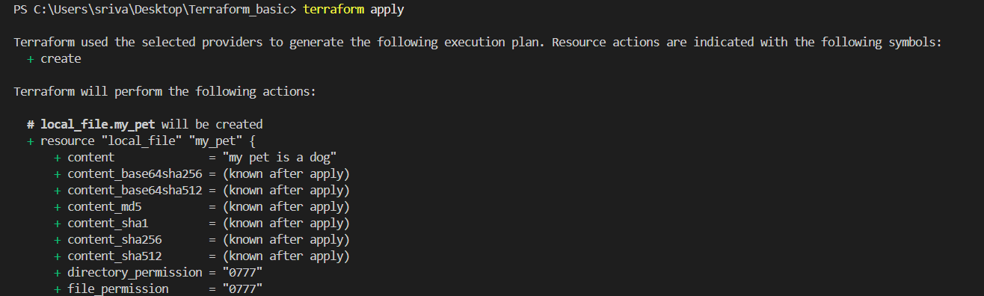
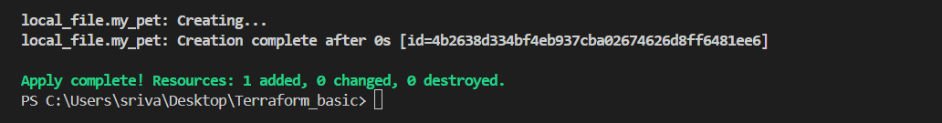
- Open your Terraform_basic folder.
- Open main.tf.
- Add:
resource "random_pet" "my_pet" {
length = 2
separator = "-"
}
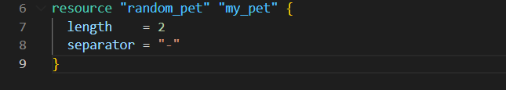
- In VS Code, click:
Terminal → New Terminal
- Run inside the VS Code terminal:
terraform init
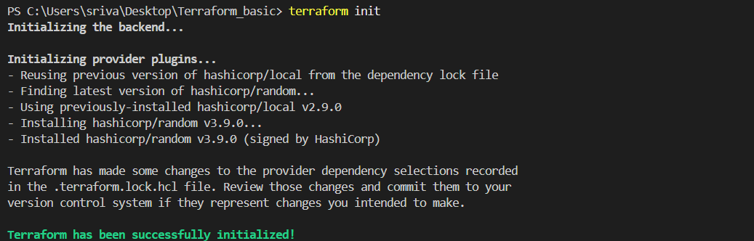
terraform plan
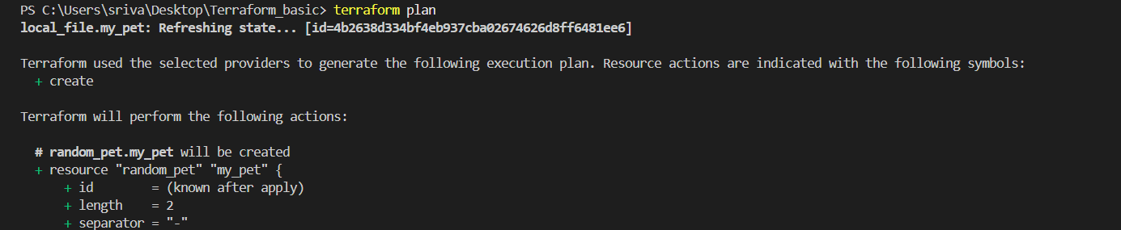
terraform apply -auto-approve
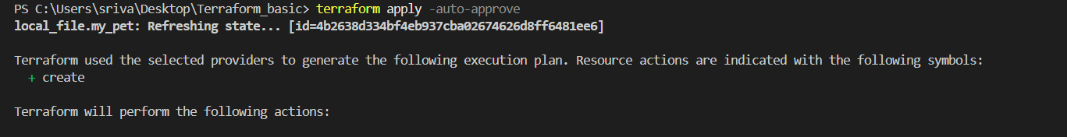
- To see the result:
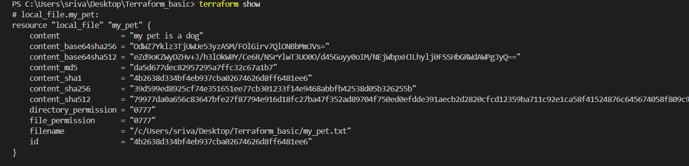
terraform show

3). Note down below points, Terraform Init Terraform Plan Terraform Apply Terraform Provider.
1. Terraform Init
- Initializes the Terraform working directory.
- Downloads required providers and modules.
- Command: terraform init
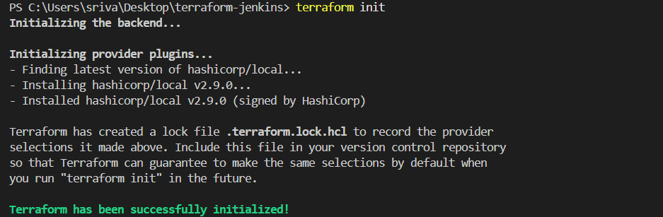
2. Terraform Plan
- Shows what Terraform will create, modify, or delete.
- Does not make changes.
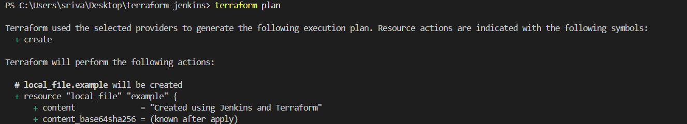
- Command: terraform plan
3. Terraform Apply
- Actually creates or modifies the infrastructure.
- Command: terraform apply
- For automatic approval: terraform apply -auto-approve
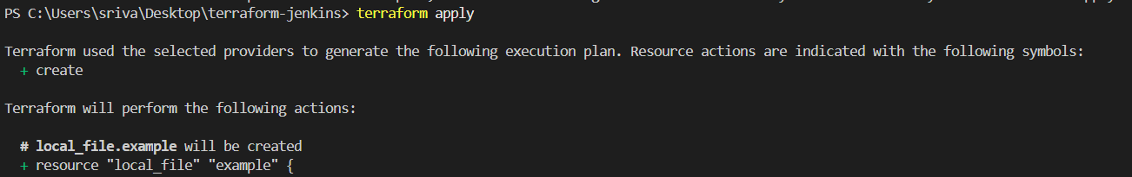
4. Terraform Provider
- A provider is a plugin that allows Terraform to communicate with a platform/service.
- Examples:
  - AWS provider → AWS resources
  - Azure provider → Azure resources
  - Google provider → GCP resources
  - Local provider → Local files

4). Integrate a sample Terraform template in Jenkins.
Step 1: Create Terraform project
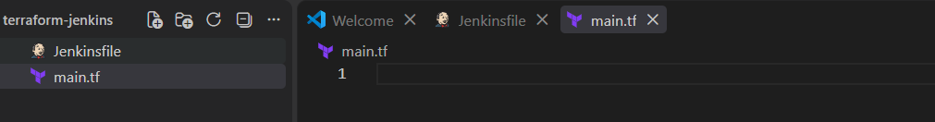
Create a project folder:

Step 2: Create main.tf
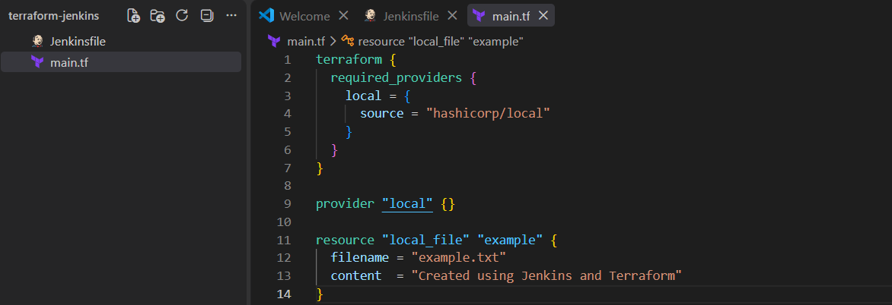
Step 3: Create Jenkinsfile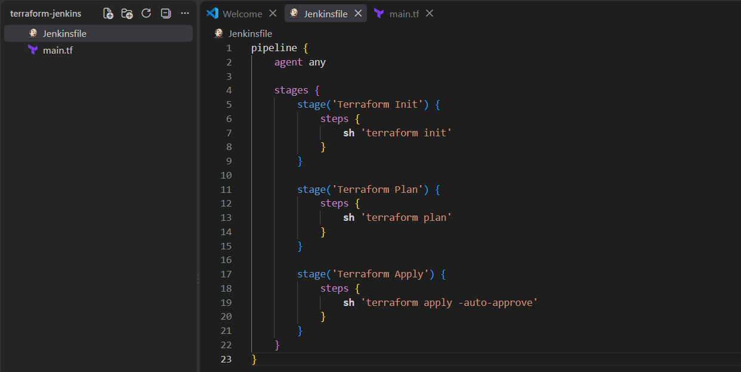
Step 4: Push the project to GitHub
From your project folder:
git init
git status
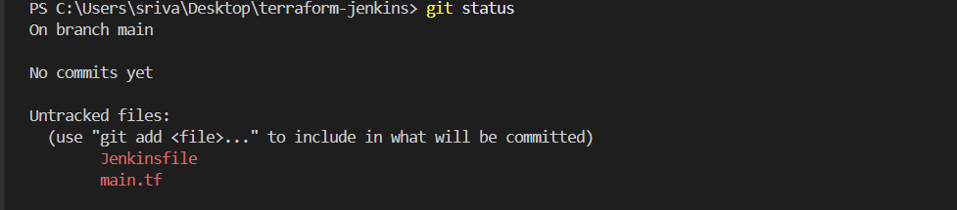
git add .
git commit -m "Terraform Jenkins integration"
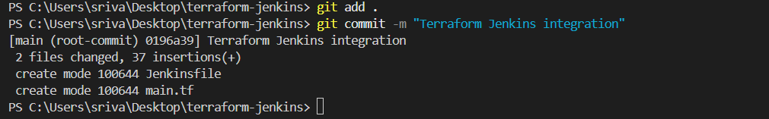
git branch -M main
git remote add origin <YOUR-GITHUB-REPO-URL>
git push -u origin main 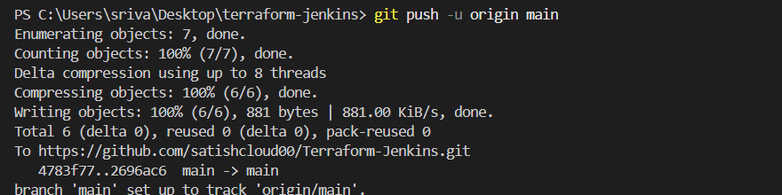

Step 5: Create Jenkins Pipeline
In Jenkins:
Dashboard → New Item → Pipeline
Give name:
terraform-jenkins
Select:
Pipeline
Click OK.
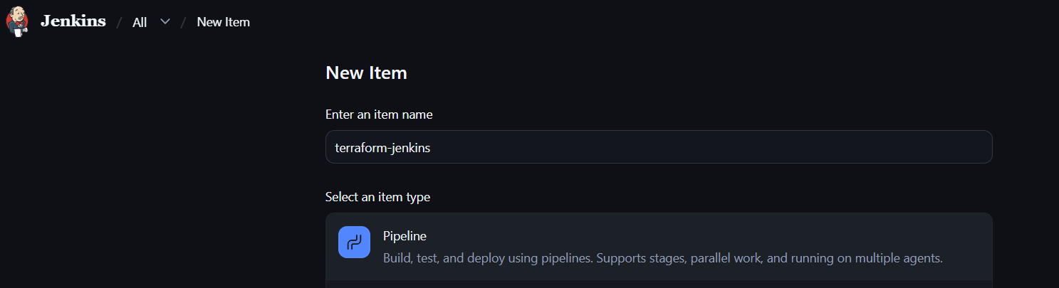
Step 6: Connect GitHub
In the Pipeline section:
Definition:
Pipeline script from SCM
SCM:
Git
Enter your GitHub repository URL.
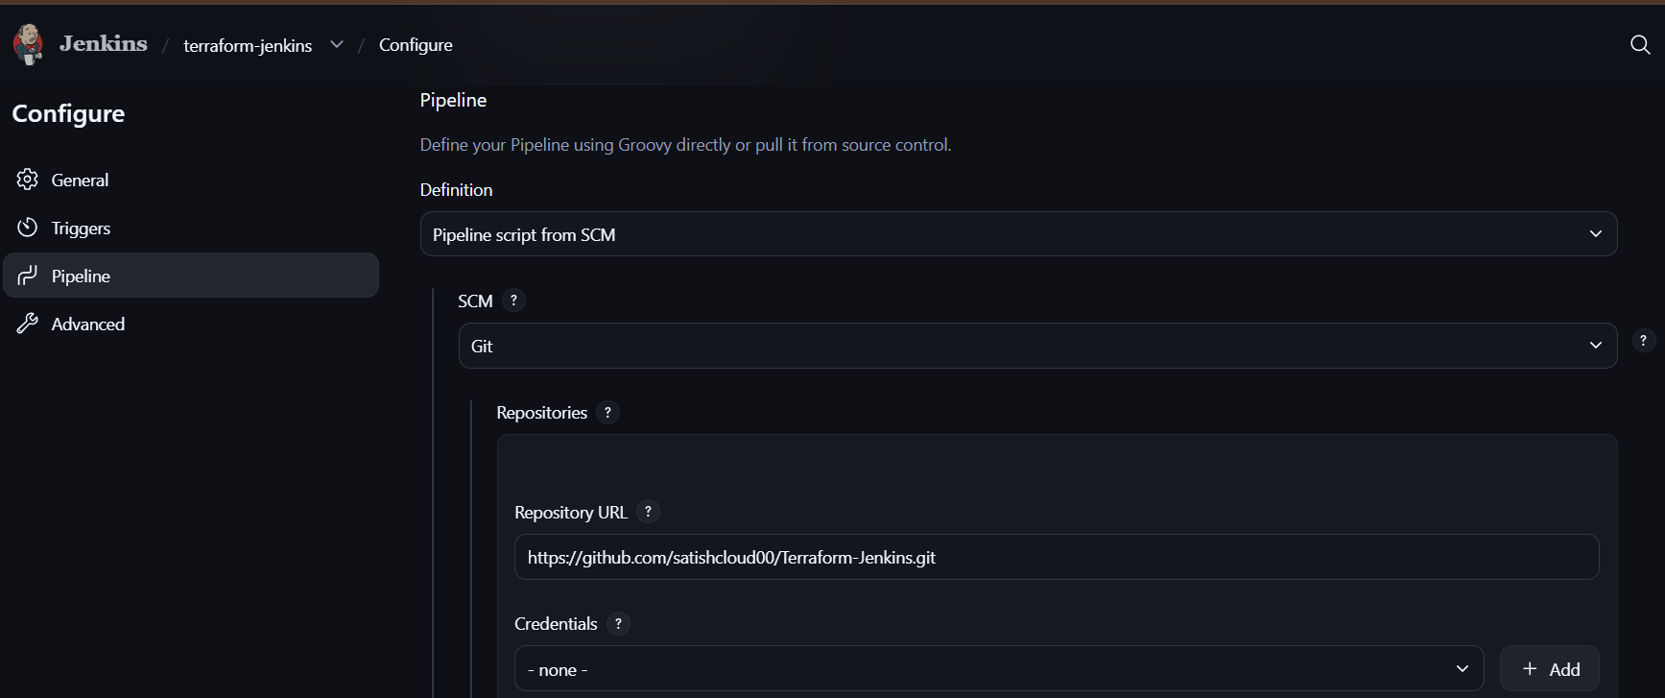
Branch:
*/main
Script Path:
Jenkinsfile
Click Save.
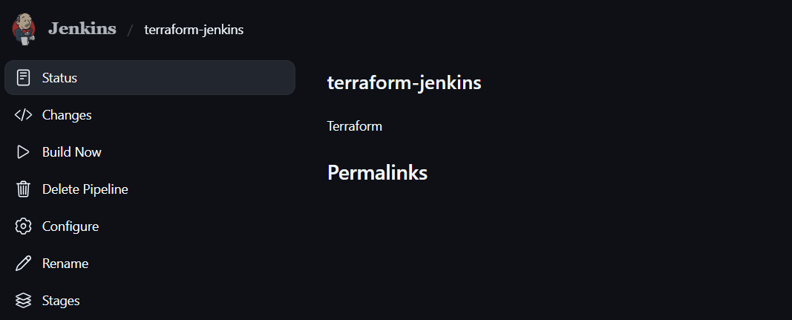
Step 7: Run the pipeline
Click:
Build Now
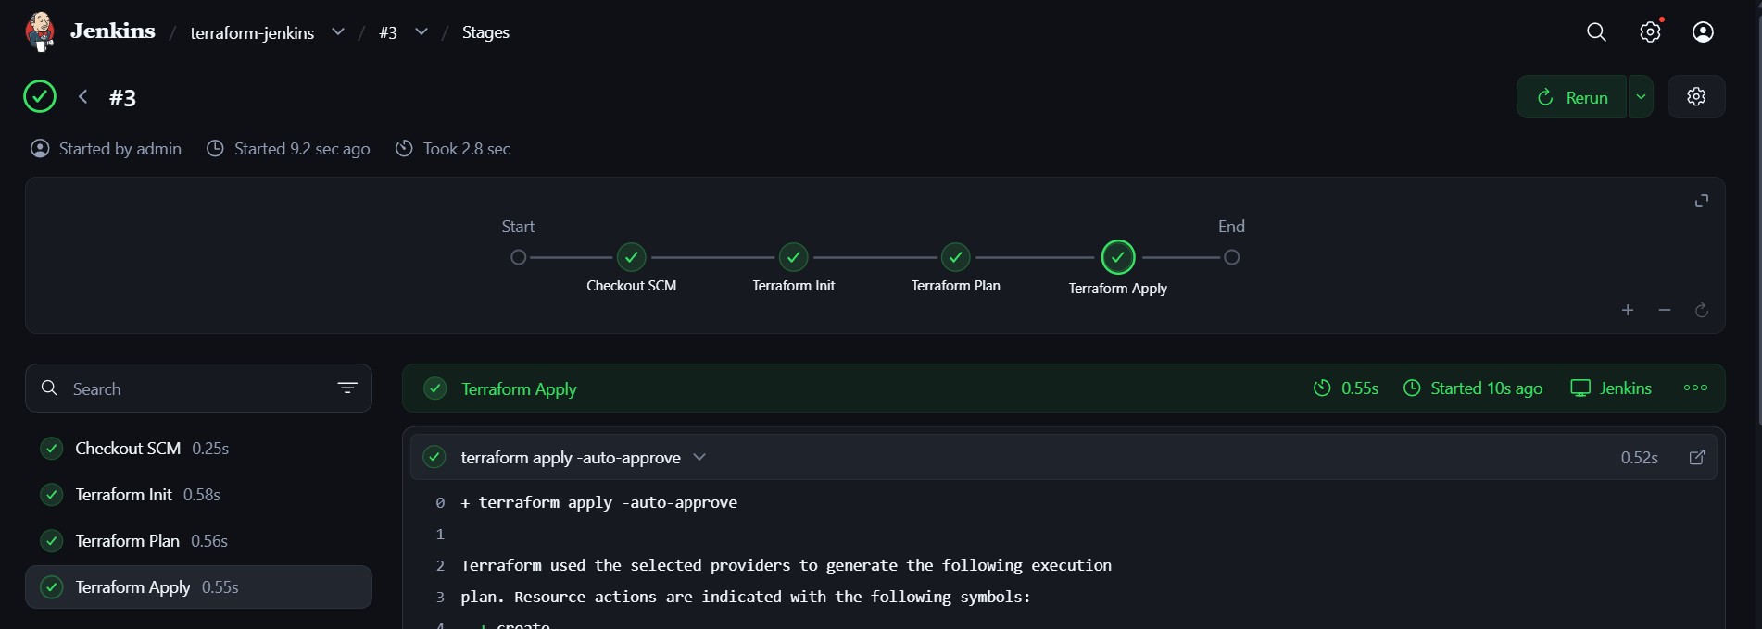
Jenkins will execute:
GitHub
↓
Jenkins
↓
terraform init
↓
terraform plan
↓
terraform apply
↓
example.txt created

Step 8: Verify

After successful build, check the Jenkins workspace:
ls
You should see:
main.tf
Jenkinsfile
example.txt
